**HOW TO APPLY FOR YOUR STUDENT RESIDENCE AUTHORIZATION CARD (TIE) - Application form (original and copy).**

- Original passport and photocopy, including visa (student type) and EU entry stamp. In case there is no EU entry-date stamp, photocopy of flight ticket or certificate of arrival issued at the police station.

- Acceptance letter (in Spanish) as student or researcher at the University of Oviedo.

- Enrolment certificate for the current academic year, specifying that attendance to classes is mandatory and the length and dates of the studies (minimum of six months).

- Certificate of census Registration in Spain (padrón o empadronamiento). This document is the Official Register of people who live in Spain, containing their corresponding address, and every resident, either Spanish or foreigner, of a municipal area must register on it. Please check Oviedo´s City Council’s website to learn more about it.

These documents must be handed in by the student/researcher within the first month after arrival in Oviedo or the Schengen Area at:

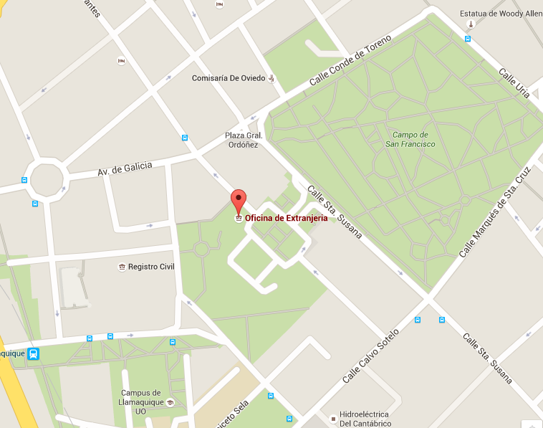

Police Station Oviedo

Plaza de España, 3, Ground floor

33071 OVIEDO, ASTURIAS

Office hours: Monday to Friday from 9.00h to 14.00h

NOTE: You are required to pay some taxes for this administrative process. The same day you bring your documents to the Police station, you will be given the taxes payment form so you can pay this fee. You will need to bring this form with you to pick up your definitive NIE.